St. Anne's Arts and Science College
Department of Computer Science

Team Members | Register No | Project Name | Phase Topic
PRIYANKA.G | 222409485 | FitTrack AI - Personalized Fitness  Recommendations Powered by AI | Phase 8  PROJECT  DEMONSTRATION
PUSHPA BIBYA.J | 222409486
REVATHY.V | 222409487
RUBA LATHA.M | 222409488

FitTrack AI
Personalized Fitness Recommendations Powered by AI

PHASE 8
PROJECT DEMONSTRATION

Project Name: AI FitTrack
Project Type: AI-powered Fitness Tracking Backend / RESTful API Application
Technology Stack: Node.js, Express.js, MongoDB, Mongoose, JWT, bcrypt.js, Google Gemini AI

CONTENTS
8.1 Demonstration Overview
8.2 Project Setup Demonstration
8.3 Authentication Demonstration
8.4 Workout Management Demonstration
8.5 AI Recommendation Demonstration
8.6 Fitness Insights Demonstration
8.7 API Testing Demonstration
8.8 Demonstration Video
8.9 API Testing / Reference Link
8.10 Final Demonstration Evidence 8.11 Phase Summary

8.1 Demonstration Overview
The final phase of FitTrack AI – Personalized Fitness Recommendations Powered by AI presents a demonstration of the completed backend application. The purpose is to showcase the principal features of the system and illustrate how the implemented RESTful APIs operate in a practical environment.
The demonstration follows the application's main workflow, beginning with user authentication and proceeding through workout management and AI-supported fitness services.

8.2 Project Setup Demonstration
The demonstration begins with the project environment and the backend server running. The presenter may briefly show the project folder structure, server execution, database connection, and required environment configuration before proceeding to API requests.
Sensitive configuration values, including secrets, credentials, and API keys, should not be exposed in screenshots or the demonstration recording.

8.3 Authentication Demonstration
Authentication is demonstrated through the registration and login APIs. The sequence shows a user registering an account and then signing in with the registered credentials. The authentication token returned after login is used to access protected resources.

8.4 Workout Management Demonstration
Workout management is demonstrated using the available workout APIs. The presentation covers the main operations supported by the backend:
- Adding a workout record.
- Viewing workout records for the authenticated user.
- Retrieving a particular workout by its identifier.
- Updating existing workout information.
- Deleting a workout record.

8.5 AI Recommendation Demonstration
The AI recommendation feature is demonstrated by submitting the required fitness information to the AI service. Inputs such as age, fitness goal, and experience level are used by the service to generate personalized fitness recommendations. The resulting output is presented through the API response.
Figure 8.4: AI Workout Recommendation Demonstration
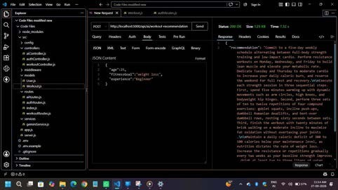

8.6 Fitness Insights Demonstration
The fitness insights feature is demonstrated using workout statistics, which may include total workouts, average workout duration, and total calories burned. The returned response illustrates the fitness-related insights generated by the AI service from the available workout information.
Figure 8.5: AI Fitness Insights Demonstration
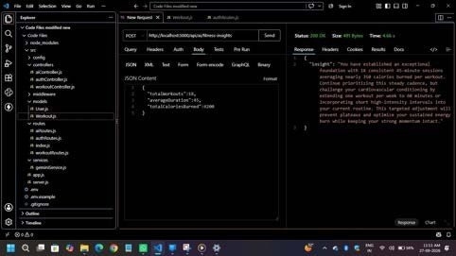

8.7 API Testing Demonstration
The implemented APIs are demonstrated using an API testing tool such as Postman or Thunder Client. The presenter sends requests to the backend and displays the corresponding JSON responses. The demonstration sequence covers the following API groups:
- Authentication APIs
- Workout APIs
- AI APIs
Where appropriate, the demonstration should show the request method, endpoint, input data, response status, and returned JSON body. The displayed results should be captured from the actual running application.

8.8 Demonstration Video
A recording of the project demonstration may be provided as supporting evidence. The video should show the running backend and the principal features presented during the project demonstration.
Demonstration Video
https://drive.google.com/file/d/1HtKapGMJfpXX0RTs4a97txQYXh_a2SJm/view?usp=drivesdk

8.9 API Testing / Reference Link
The API testing collection or other relevant project reference link may be included in this section to support evaluation and verification.
API Testing / Reference Link
https://drive.google.com/file/d/16qFrrqSGHthvvi6P5r5F0ME1VRX3_sl8/view?usp=drivesdk

8.10 Final Demonstration Evidence
The final demonstration provides practical evidence of the major components of AI FitTrack and their accessibility through the implemented APIs. It brings together authentication, workout management, database interaction, and AI-based recommendation and fitness-insight features developed during the project.
The final evidence package may include the screenshots and links identified in this phase. All placeholders should be replaced only with genuine screenshots, recordings, and working references from the project.
Figure 8.6: Consolidated Final Demonstration Evidence
https://drive.google.com/file/d/1HtKapGMJfpXX0RTs4a97txQYXh_a2SJm/view?usp=drivesdk

8.11 Phase Summary
This phase presents the demonstration sequence for the AI FitTrack backend, from project setup and authentication to workout operations and AI-powered fitness services. Screenshots, a demonstration recording, and API reference links can be added to document the live demonstration and support project evaluation.

